Computer Vision sfm Lab
Luca Sichi, 19-928-100

Essential Matrix Estimation:
I first used np to inverse K, then I used np’s matmul function to calculate the homogenized keypoints times the inverse of K.

Triangulate Points
Here we use masks to decide if the keypoints are visible from both cameras.

Essential Matrix Decomposition
We first set the pose of im2 to the “default” pose, then we loop over the poses and decide us for two depending on how many points we see.

Absolute Pose Estimation
We again calculate the inverse of K and calculate the normalized points in 2D

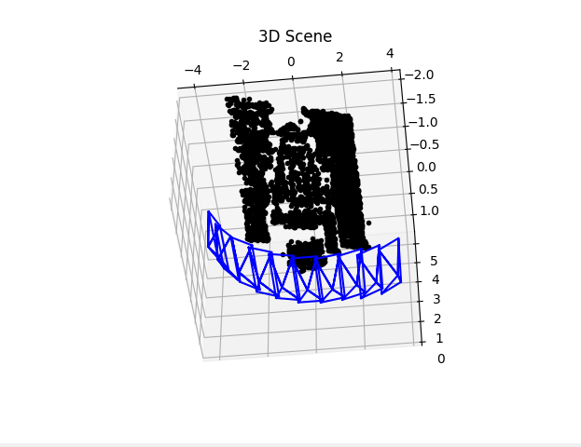
Here you can see a screenshot of the final 3D scene. One can see the camera poses and the 3d structure.

RANSAC
Here I just implemented the Ransac algorithm similar to the lecture and according to the comments and hints in the code skeleton.
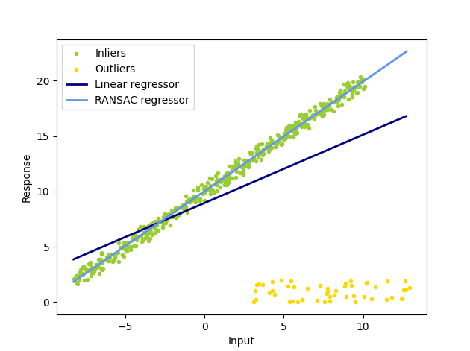
1 10 0.6159656578755459 8.96172714144364 0.9893824756873283 10.027468068986911. These are the estimated parameters as printed by the program.

Here we can clearly see a good performance on the provided test data.

